

Reporte de Piezas

PRESENTADORES:

Josue Adrian moreno martinez   
jose german mendez rodriguez  
leonardo martinez chavez  
edgar moises cuevas gonzales

Tlajomulco de Zúñiga, Jalisco, México Febrero 1 del 2019



**Project**

|  |  |
| --- | --- |
| First Saved | Thursday, January 31, 2019 |
| Last Saved | Thursday, January 31, 2019 |
| Product Version | 19.1 Release |
| Save Project Before Solution | No |
| Save Project After Solution | No |

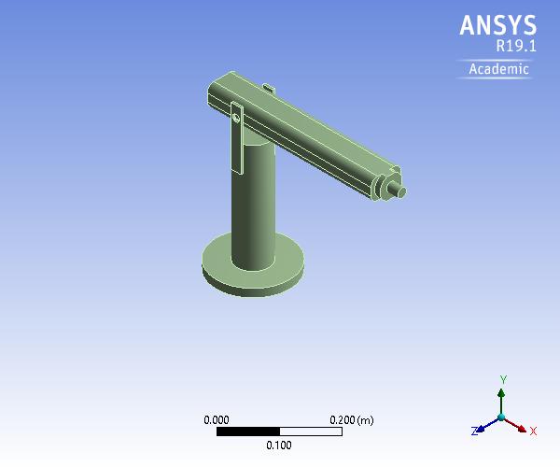

**Contents**

* **Units**
* **Model (A4)**
  + Geometry
    - SYS\Solid
  + Materials
    - Structural Steel
  + Coordinate Systems
  + Connections
    - Contacts
  + Mesh
  + **Static Structural (A5)**
    - Analysis Settings
    - Loads
    - Solution (A6)
      * Solution Information
* **Material Data**
  + Structural Steel

**Report Not Finalized**

**Not all objects described below are in a finalized state.** As a result, data may be incomplete, obsolete or in error. View first state problem. To finalize this report, edit objects as needed and solve the analyses.

**Units**

**TABLE 1**

|  |  |
| --- | --- |
| Unit System | Metric (m, kg, N, s, V, A) Degrees rad/s Celsius |
| Angle | Degrees |
| Rotational Velocity | rad/s |
| Temperature | Celsius |

**Model (A4)**

***Geometry***

**TABLE 2  
Model (A4) > Geometry**

|  |  |
| --- | --- |
| Object Name | *Geometry* |
| State | Fully Defined |
| **Definition** | |
| Source | C:\Users\JosueMorenoMtz\AppData\Local\Temp\WB_DESKTOP-SRRC06L_JosueMorenoMtz_4784_3\unsaved_project_files\dp0\SYS\DM\SYS.scdoc |
| Type | SpaceClaim |
| Length Unit | Meters |
| Element Control | Program Controlled |
| Display Style | Body Color |
| **Bounding Box** | |
| Length X | 0.41909 m |
| Length Y | 0.339 m |
| Length Z | 0.16418 m |
| **Properties** | |
| Volume | 2.4859e-003 m³ |
| Mass | 19.514 kg |
| Scale Factor Value | 1. |
| **Statistics** | |
| Bodies | 1 |
| Active Bodies | 1 |
| Nodes | 4155 |
| Elements | 2240 |
| Mesh Metric | None |
| **Update Options** | |
| Assign Default Material | No |
| **Basic Geometry Options** | |
| Solid Bodies | Yes |
| Surface Bodies | Yes |
| Line Bodies | Yes |
| Parameters | Independent |
| Parameter Key |  |
| Attributes | Yes |
| Attribute Key |  |
| Named Selections | Yes |
| Named Selection Key |  |
| Material Properties | Yes |
| **Advanced Geometry Options** | |
| Use Associativity | Yes |
| Coordinate Systems | Yes |
| Coordinate System Key |  |
| Reader Mode Saves Updated File | No |
| Use Instances | Yes |
| Smart CAD Update | Yes |
| Compare Parts On Update | No |
| Analysis Type | 3-D |
| Mixed Import Resolution | None |
| Decompose Disjoint Geometry | Yes |
| Enclosure and Symmetry Processing | Yes |

**TABLE 3  
Model (A4) > Geometry > Parts**

|  |  |
| --- | --- |
| Object Name | *SYS\Solid* |
| State | Meshed |
| **Graphics Properties** | |
| Visible | Yes |
| Transparency | 1 |
| **Definition** | |
| Suppressed | No |
| Stiffness Behavior | Flexible |
| Coordinate System | Default Coordinate System |
| Reference Temperature | By Environment |
| Behavior | None |
| **Material** | |
| Assignment | Structural Steel |
| Nonlinear Effects | Yes |
| Thermal Strain Effects | Yes |
| **Bounding Box** | |
| Length X | 0.41909 m |
| Length Y | 0.339 m |
| Length Z | 0.16418 m |
| **Properties** | |
| Volume | 2.4859e-003 m³ |
| Mass | 19.514 kg |
| Centroid X | 5.4487e-002 m |
| Centroid Y | 0.20065 m |
| Centroid Z | -1.6754e-004 m |
| Moment of Inertia Ip1 | 0.38396 kg·m² |
| Moment of Inertia Ip2 | 0.11627 kg·m² |
| Moment of Inertia Ip3 | 0.47904 kg·m² |
| **Statistics** | |
| Nodes | 4155 |
| Elements | 2240 |
| Mesh Metric | None |
| **CAD Attributes** | |
| PartTolerance: | 0.00000001 |
| Color:143.175.143 |  |

***Coordinate Systems***

**TABLE 4  
Model (A4) > Coordinate Systems > Coordinate System**

|  |  |
| --- | --- |
| Object Name | *Global Coordinate System* |
| State | Fully Defined |
| **Definition** | |
| Type | Cartesian |
| Coordinate System ID | 0. |
| **Origin** | |
| Origin X | 0. m |
| Origin Y | 0. m |
| Origin Z | 0. m |
| **Directional Vectors** | |
| X Axis Data | [ 1. 0. 0. ] |
| Y Axis Data | [ 0. 1. 0. ] |
| Z Axis Data | [ 0. 0. 1. ] |

***Connections***

**TABLE 5  
Model (A4) > Connections**

|  |  |
| --- | --- |
| Object Name | *Connections* |
| State | Fully Defined |
| **Auto Detection** | |
| Generate Automatic Connection On Refresh | Yes |
| **Transparency** | |
| Enabled | Yes |

**TABLE 6  
Model (A4) > Connections > Contacts**

|  |  |
| --- | --- |
| Object Name | *Contacts* |
| State | Fully Defined |
| **Definition** | |
| Connection Type | Contact |
| **Scope** | |
| Scoping Method | Geometry Selection |
| Geometry | All Bodies |
| **Auto Detection** | |
| Tolerance Type | Slider |
| Tolerance Slider | 0. |
| Tolerance Value | 1.4087e-003 m |
| Use Range | No |
| Face/Face | Yes |
| Face Overlap Tolerance | Off |
| Cylindrical Faces | Include |
| Face/Edge | No |
| Edge/Edge | No |
| Priority | Include All |
| Group By | Bodies |
| Search Across | Bodies |
| **Statistics** | |
| Connections | 0 |
| Active Connections | 0 |

***Mesh***

**TABLE 7  
Model (A4) > Mesh**

|  |  |
| --- | --- |
| Object Name | *Mesh* |
| State | Solved |
| **Display** | |
| Display Style | Body Color |
| **Defaults** | |
| Physics Preference | Mechanical |
| Element Order | Program Controlled |
| Element Size | Default (2.8174e-002 m) |
| **Sizing** | |
| Use Adaptive Sizing | No |
| Growth Rate | Default (1.85) |
| Max Size | Default (5.6348e-002 m) |
| Mesh Defeaturing | Yes |
| Defeature Size | Default (1.4087e-004 m) |
| Capture Curvature | Yes |
| Curvature Min Size | Default (2.8174e-004 m) |
| Curvature Normal Angle | Default (70.395°) |
| Capture Proximity | No |
| Bounding Box Diagonal | 0.56348 m |
| Average Surface Area | 5.0823e-003 m² |
| Minimum Edge Length | 4.444e-003 m |
| **Quality** | |
| Check Mesh Quality | Yes, Errors |
| Error Limits | Standard Mechanical |
| Target Quality | Default (0.050000) |
| Smoothing | Medium |
| Mesh Metric | None |
| **Inflation** | |
| Use Automatic Inflation | None |
| Inflation Option | Smooth Transition |
| Transition Ratio | 0.272 |
| Maximum Layers | 5 |
| Growth Rate | 1.2 |
| Inflation Algorithm | Pre |
| View Advanced Options | No |
| **Advanced** | |
| Number of CPUs for Parallel Part Meshing | Program Controlled |
| Straight Sided Elements | No |
| Rigid Body Behavior | Dimensionally Reduced |
| Triangle Surface Mesher | Program Controlled |
| Topology Checking | Yes |
| Pinch Tolerance | Default (2.5357e-004 m) |
| Generate Pinch on Refresh | No |
| **Statistics** | |
| Nodes | 4155 |
| Elements | 2240 |

**Static Structural (A5)**

**TABLE 8  
Model (A4) > Analysis**

|  |  |
| --- | --- |
| Object Name | *Static Structural (A5)* |
| State | Not Solved |
| **Definition** | |
| Physics Type | Structural |
| Analysis Type | Static Structural |
| Solver Target | Mechanical APDL |
| **Options** | |
| Environment Temperature | 22. °C |
| Generate Input Only | No |

**TABLE 9  
Model (A4) > Static Structural (A5) > Analysis Settings**

|  |  |
| --- | --- |
| Object Name | *Analysis Settings* |
| State | Fully Defined |
| **Step Controls** | |
| Number Of Steps | 1. |
| Current Step Number | 1. |
| Step End Time | 1. s |
| Auto Time Stepping | Program Controlled |
| **Solver Controls** | |
| Solver Type | Program Controlled |
| Weak Springs | Off |
| Solver Pivot Checking | Program Controlled |
| Large Deflection | Off |
| Inertia Relief | Off |
| **Rotordynamics Controls** | |
| Coriolis Effect | Off |
| **Restart Controls** | |
| Generate Restart Points | Program Controlled |
| Retain Files After Full Solve | No |
| Combine Restart Files | Program Controlled |
| **Nonlinear Controls** | |
| Newton-Raphson Option | Program Controlled |
| Force Convergence | Program Controlled |
| Moment Convergence | Program Controlled |
| Displacement Convergence | Program Controlled |
| Rotation Convergence | Program Controlled |
| Line Search | Program Controlled |
| Stabilization | Off |
| **Output Controls** | |
| Stress | Yes |
| Strain | Yes |
| Nodal Forces | No |
| Contact Miscellaneous | No |
| General Miscellaneous | No |
| Store Results At | All Time Points |
| **Analysis Data Management** | |
| Solver Files Directory | C:\Users\JosueMorenoMtz\AppData\Local\Temp\WB_DESKTOP-SRRC06L_JosueMorenoMtz_4784_3\unsaved_project_files\dp0\SYS\MECH\ |
| Future Analysis | None |
| Scratch Solver Files Directory |  |
| Save MAPDL db | No |
| Contact Summary | Program Controlled |
| Delete Unneeded Files | Yes |
| Nonlinear Solution | No |
| Solver Units | Active System |
| Solver Unit System | mks |

**TABLE 10  
Model (A4) > Static Structural (A5) > Loads**

|  |  |  |  |
| --- | --- | --- | --- |
| Object Name | *Pressure* | *Force* | *Line Pressure* |
| State | Fully Defined | | |
| **Scope** | | | |
| Scoping Method | Geometry Selection | | |
| Geometry | 1 Face | | 1 Edge |
| **Definition** | | | |
| Type | Pressure | Force | Line Pressure |
| Define By | Normal To | Vector | |
| Applied By | Surface Effect |  | |
| Magnitude | 12. Pa (ramped) | 5. N (ramped) | 12. N/m (ramped) |
| Suppressed | No | | |
| Direction |  | Defined | |

**FIGURE 1  
Model (A4) > Static Structural (A5) > Pressure**

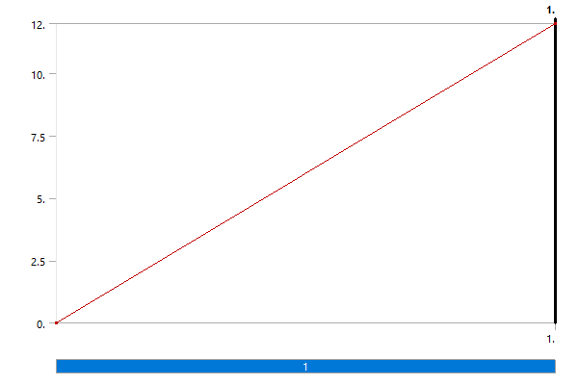

**FIGURE 2  
Model (A4) > Static Structural (A5) > Force**

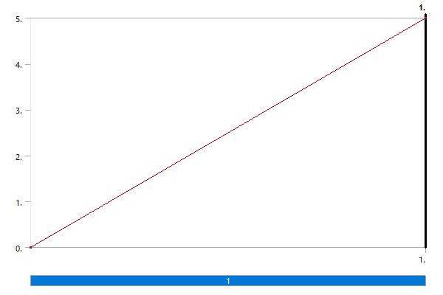

**FIGURE 3  
Model (A4) > Static Structural (A5) > Line Pressure**

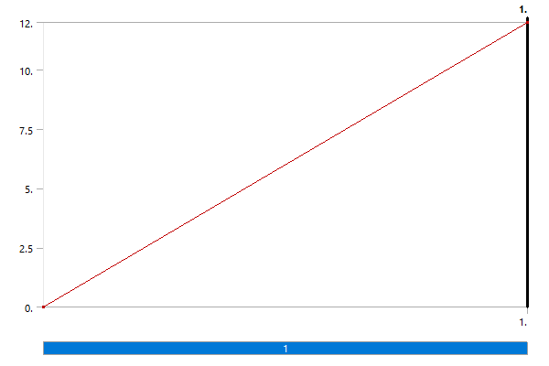

***Solution (A6)***

**TABLE 11  
Model (A4) > Static Structural (A5) > Solution**

|  |  |
| --- | --- |
| Object Name | *Solution (A6)* |
| State | Solve Failed |
| **Adaptive Mesh Refinement** | |
| Max Refinement Loops | 1. |
| Refinement Depth | 2. |
| **Information** | |
| Status | Solve Required |
| MAPDL Elapsed Time | 3. s |
| MAPDL Memory Used | 266. MB |
| MAPDL Result File Size |  |
| **Post Processing** | |
| Beam Section Results | No |
| On Demand Stress/Strain | No |

**TABLE 12  
Model (A4) > Static Structural (A5) > Solution (A6) > Solution Information**

|  |  |
| --- | --- |
| Object Name | *Solution Information* |
| State | Solve Failed |
| **Solution Information** | |
| Solution Output | Solver Output |
| Newton-Raphson Residuals | 0 |
| Identify Element Violations | 0 |
| Update Interval | 2.5 s |
| Display Points | All |
| **FE Connection Visibility** | |
| Activate Visibility | Yes |
| Display | All FE Connectors |
| Draw Connections Attached To | All Nodes |
| Line Color | Connection Type |
| Visible on Results | No |
| Line Thickness | Single |
| Display Type | Lines |

**Material Data**

***Structural Steel***

**TABLE 13  
Structural Steel > Constants**

|  |  |
| --- | --- |
| Density | 7850 kg m^-3 |
| Isotropic Secant Coefficient of Thermal Expansion | 1.2e-005 C^-1 |
| Specific Heat Constant Pressure | 434 J kg^-1 C^-1 |
| Isotropic Thermal Conductivity | 60.5 W m^-1 C^-1 |
| Isotropic Resistivity | 1.7e-007 ohm m |

**TABLE 14  
Structural Steel > Color**

|  |  |  |
| --- | --- | --- |
| Red | Green | Blue |
| 132 | 139 | 179 |

**TABLE 15  
Structural Steel > Compressive Ultimate Strength**

|  |
| --- |
| Compressive Ultimate Strength Pa |
| 0 |

**TABLE 16  
Structural Steel > Compressive Yield Strength**

|  |
| --- |
| Compressive Yield Strength Pa |
| 2.5e+008 |

**TABLE 17  
Structural Steel > Tensile Yield Strength**

|  |
| --- |
| Tensile Yield Strength Pa |
| 2.5e+008 |

**TABLE 18  
Structural Steel > Tensile Ultimate Strength**

|  |
| --- |
| Tensile Ultimate Strength Pa |
| 4.6e+008 |

**TABLE 19  
Structural Steel > Isotropic Secant Coefficient of Thermal Expansion**

|  |
| --- |
| Zero-Thermal-Strain Reference Temperature C |
| 22 |

**TABLE 20  
Structural Steel > S-N Curve**

|  |  |  |
| --- | --- | --- |
| Alternating Stress Pa | Cycles | Mean Stress Pa |
| 3.999e+009 | 10 | 0 |
| 2.827e+009 | 20 | 0 |
| 1.896e+009 | 50 | 0 |
| 1.413e+009 | 100 | 0 |
| 1.069e+009 | 200 | 0 |
| 4.41e+008 | 2000 | 0 |
| 2.62e+008 | 10000 | 0 |
| 2.14e+008 | 20000 | 0 |
| 1.38e+008 | 1.e+005 | 0 |
| 1.14e+008 | 2.e+005 | 0 |
| 8.62e+007 | 1.e+006 | 0 |

**TABLE 21  
Structural Steel > Strain-Life Parameters**

|  |  |  |  |  |  |
| --- | --- | --- | --- | --- | --- |
| Strength Coefficient Pa | Strength Exponent | Ductility Coefficient | Ductility Exponent | Cyclic Strength Coefficient Pa | Cyclic Strain Hardening Exponent |
| 9.2e+008 | -0.106 | 0.213 | -0.47 | 1.e+009 | 0.2 |

**TABLE 22  
Structural Steel > Isotropic Elasticity**

|  |  |  |  |  |
| --- | --- | --- | --- | --- |
| Young's Modulus Pa | Poisson's Ratio | Bulk Modulus Pa | Shear Modulus Pa | Temperature C |
| 2.e+011 | 0.3 | 1.6667e+011 | 7.6923e+010 |  |

**TABLE 23  
Structural Steel > Isotropic Relative Permeability**

|  |
| --- |
| Relative Permeability |
| 10000 |